WEEK-1 PRACTICAL
- Id:
Report: I used the id command to display information about the current user. It showed my user ID, group ID and the groups associated with my user account.

- Env:
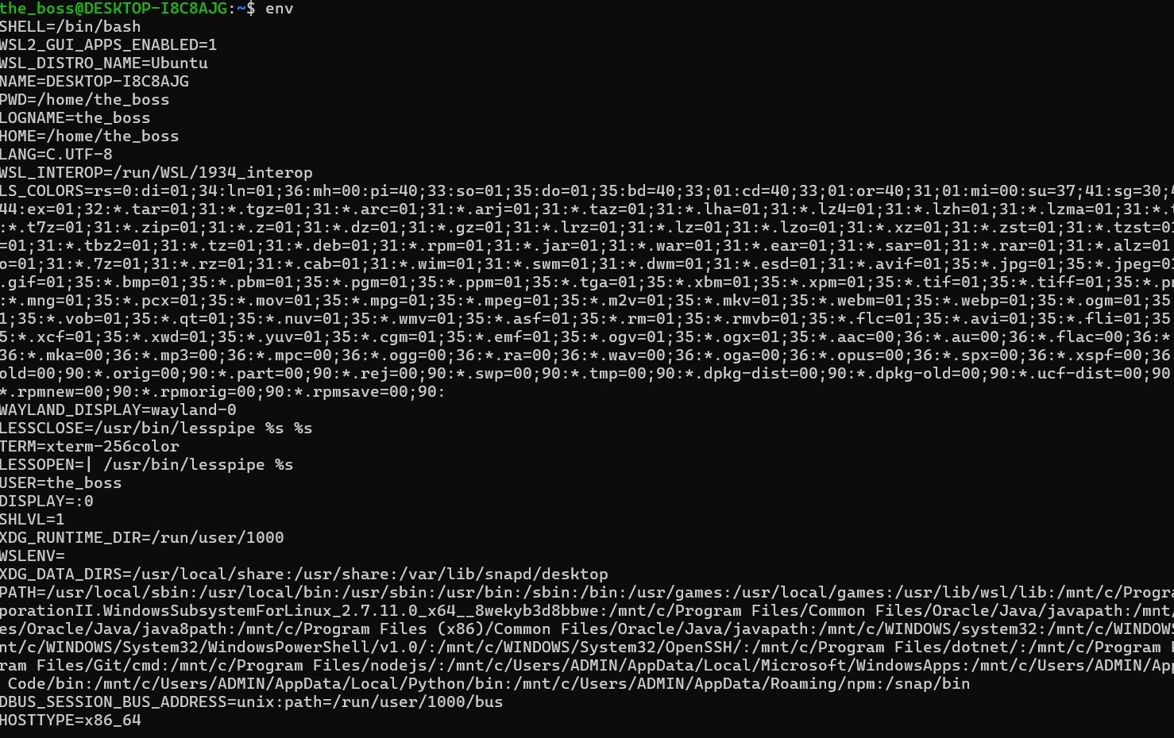
Report: I used the env command to display the environment variables available in my current shell. It helped me understand the different settings and variables used by the system.

3.export:
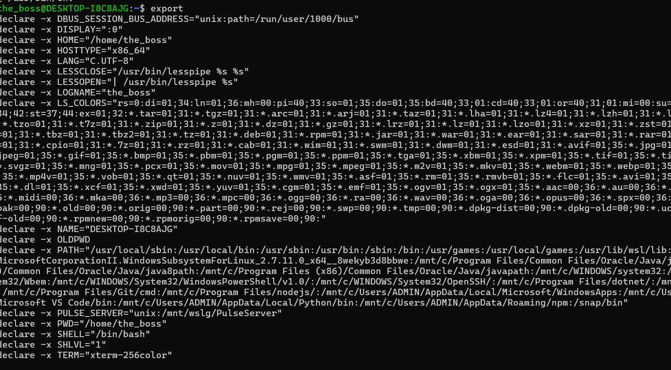
Report: I used the export command to create or set an environment variable. The variable can then be accessed by commands and programs running from the current shell.

- Alias:
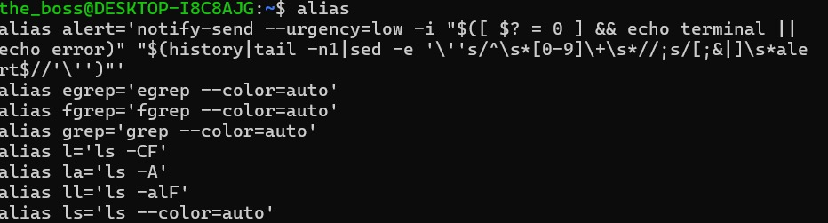
Report: I used the alias command to create a short name for a command. It helps me execute frequently used commands more easily without typing the complete command every time.

